
Institutional Assessment
Submitted by:
Roco, Jaymar S.
Submitted to:
Mr. Benz Vincent A. Geraldizo

- Project Overview
  - Project Title: Simple Banking System
  - Project Description: The Banking System Application is desktop-based software designed to manage and maintain bank accounts. It provides functionalities for creating accounts, checking balances, making deposits, and handling transactions securely and efficiently. The system interacts with a MySQL database to store and retrieve account information.
- Key Features
  - Account Management: Create, update, and delete bank accounts.
  - Balance Inquiry: Check the current balance of any account using its ID.
  - Deposit Functionality: Add funds to a specified account.
  - User Interface: Intuitive GUI using Java Swing for easy navigation.
  - Database Integration: Uses MySQL to securely store account data.
- Technology Used
  - Programming Language: Java
  - GUI Framework: Java Swing
  - Database: MySQL
  - Development Tools: NetBeans
  - Connectivity: JDBC for database communication
- Screenshot of the System
  - Menu
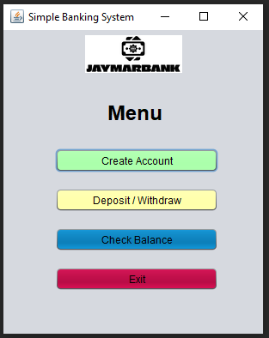

  - Create Account
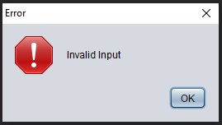
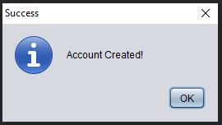
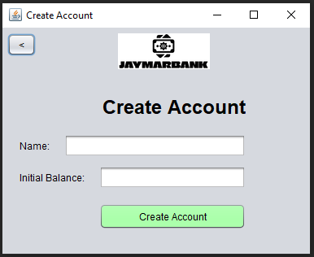

  - Transaction
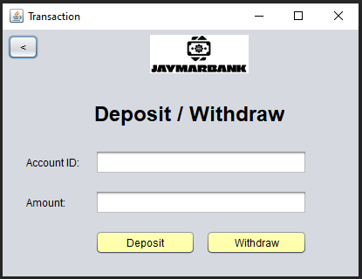




  - Account Table (The account table will be displayed after choosing either of the two transactions. It will show real-time updates from the database.)
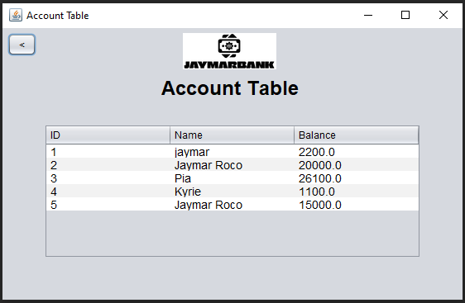

  - Check Balance

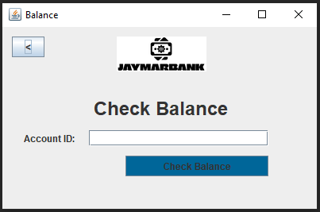

  - Folder Structure
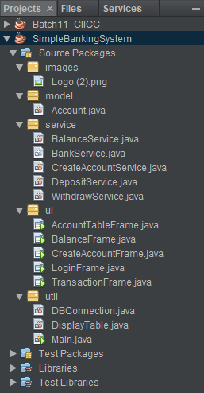

- Model
  - Account.java
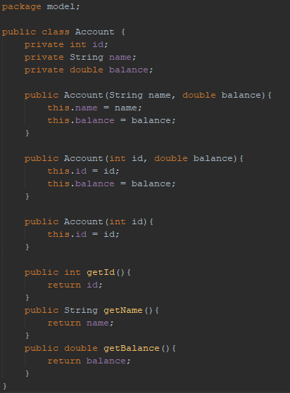

- Service
  - BalanceService.java
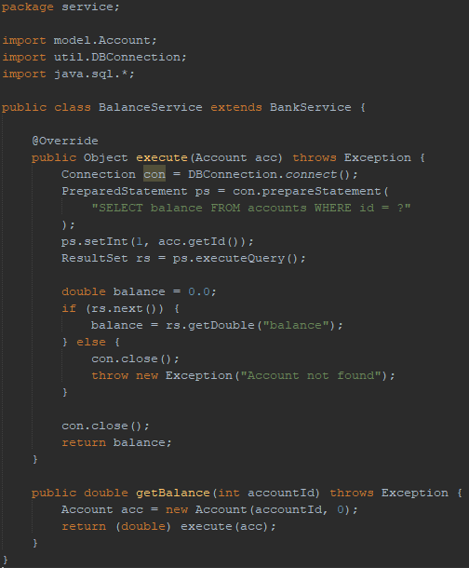

  - CreateAccountService.java
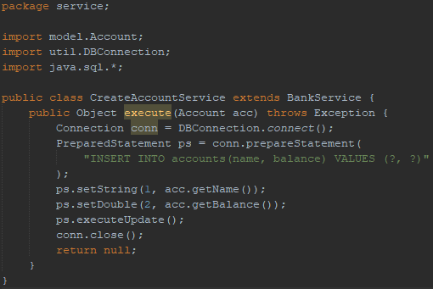

  - DepositService.java
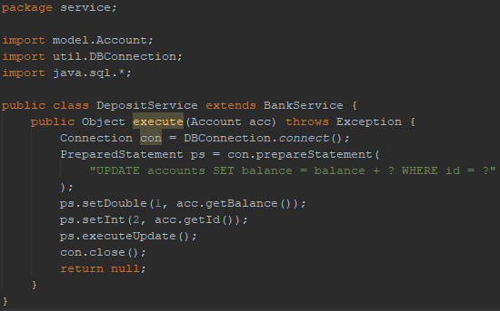

  - WithdrawService.java
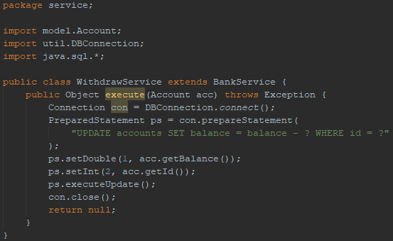

- UI
  - AccountTableFrame.java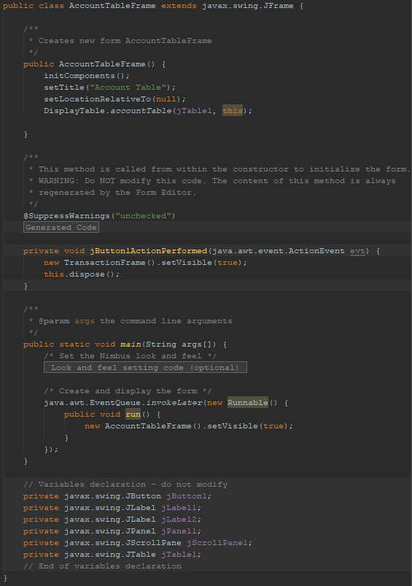

  - BalanceFrame.java
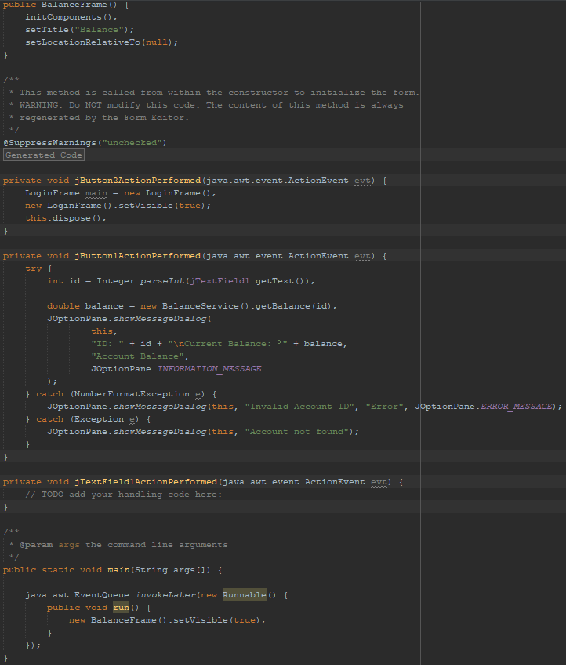

  - CreateAccountFrame.java
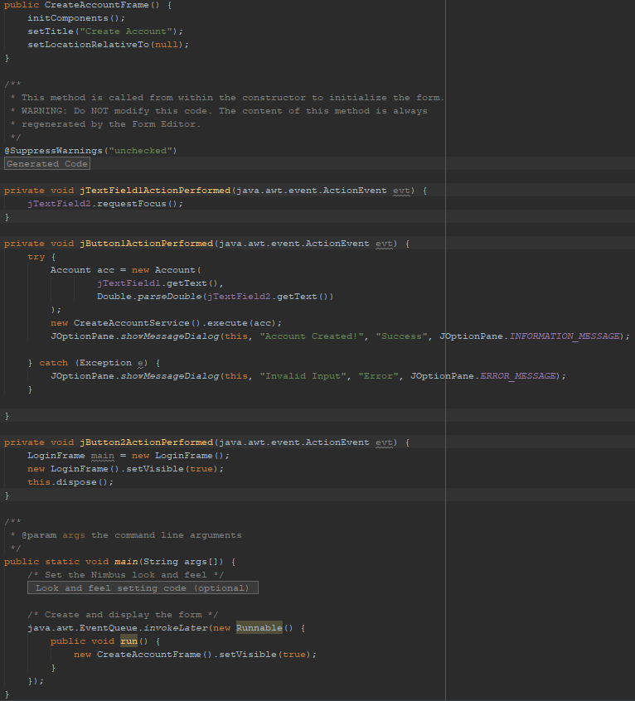

  - LoginFrame.java
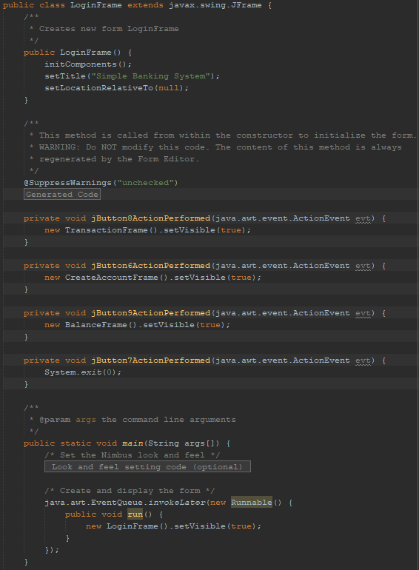

  - TransactionFrame.java
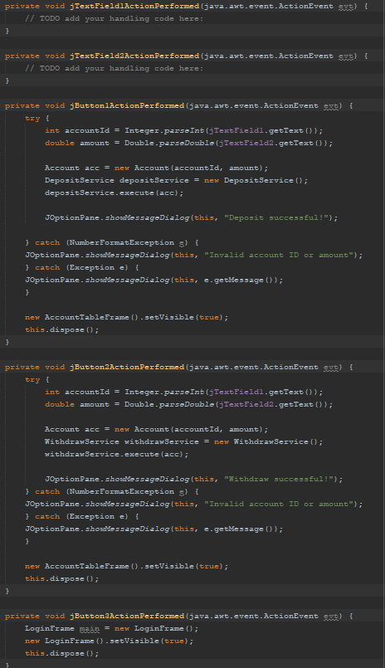
- UTIL
  - DBConnection.java
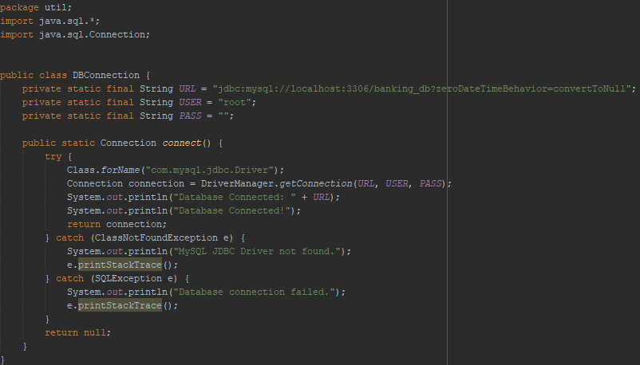

  - DisplayTable.java
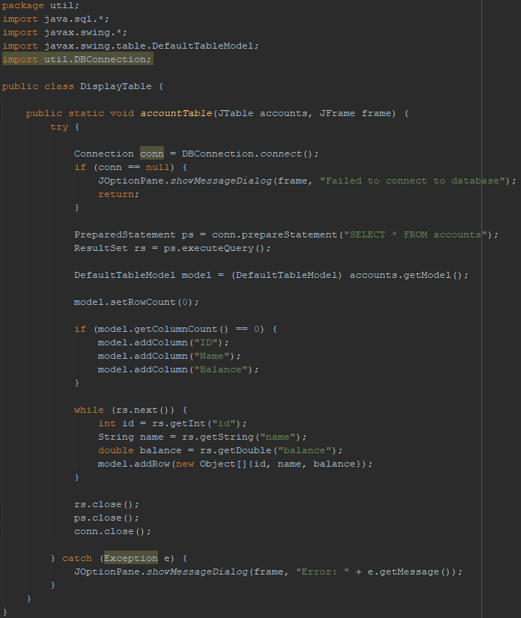

  - Main.java
